Lab Report : Rocket Ship Project

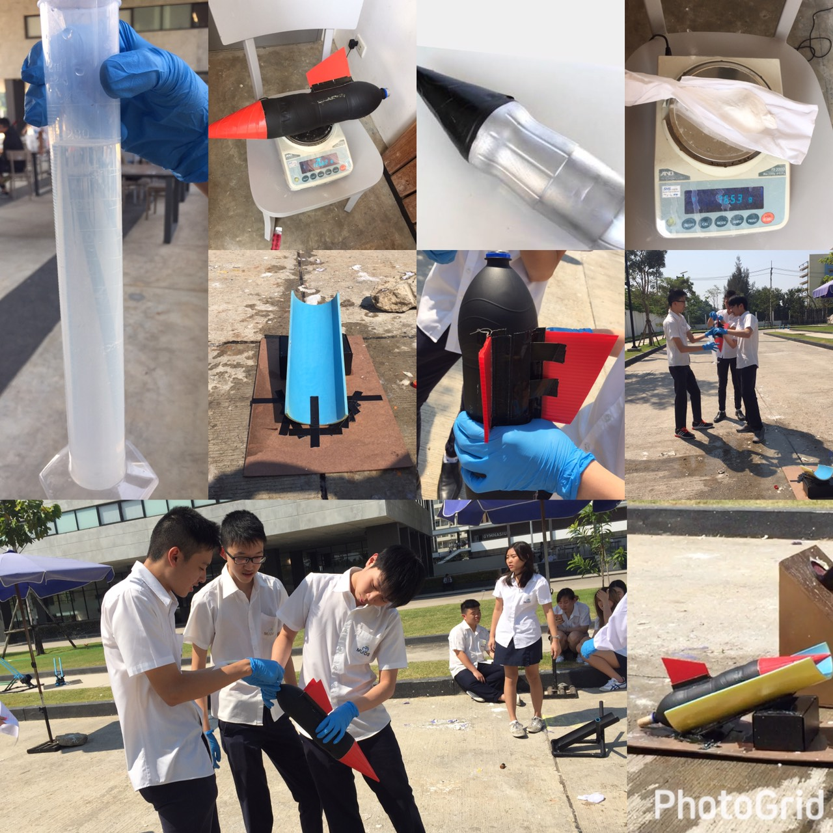

Team Name : Meaw Ngao
Member
Janista Chaikanjanasak (Eye)
Kooltawatch Jeerataweesook (Tae)
Chirateep Chatchonbut (Win)
Viwat Eakkaparksawat (Ton)
1005

As a work for Ms. Susana Alulod
Mahidol University International Demonstration School

Abstract

Our objective is to design a vinegar-baking soda rocket and to cooperate them with the appropriate concepts in physics. We begins with the manufacturing process - using water bottles, glue, cutter, plastic board, baking soda, vinegar, vine cock. After the making process is completed, we took them on a field test, the results we’ve got is quite impressive - mass was 126.62g total distance was 14m and the angle we use to launched was 35 degrees. We’ve came out with a solution that the quantity of chemical compound that putting in the rocket to make it fly is appropriate for both mass and size. However, our problem was the launcher angle can’t be adjusted - it was 35 degree fixed. That is the reason why our rocket cannot reach the target but it can only reach 14 meters as the furthest distance.

Objective
To design and build a rocket with the appropraite concepts in physics

Material

1. water bottles
2. glue
3. cutter
4. fillter board
5. baking soda
6. vinegar
7. vine cock

Drawing
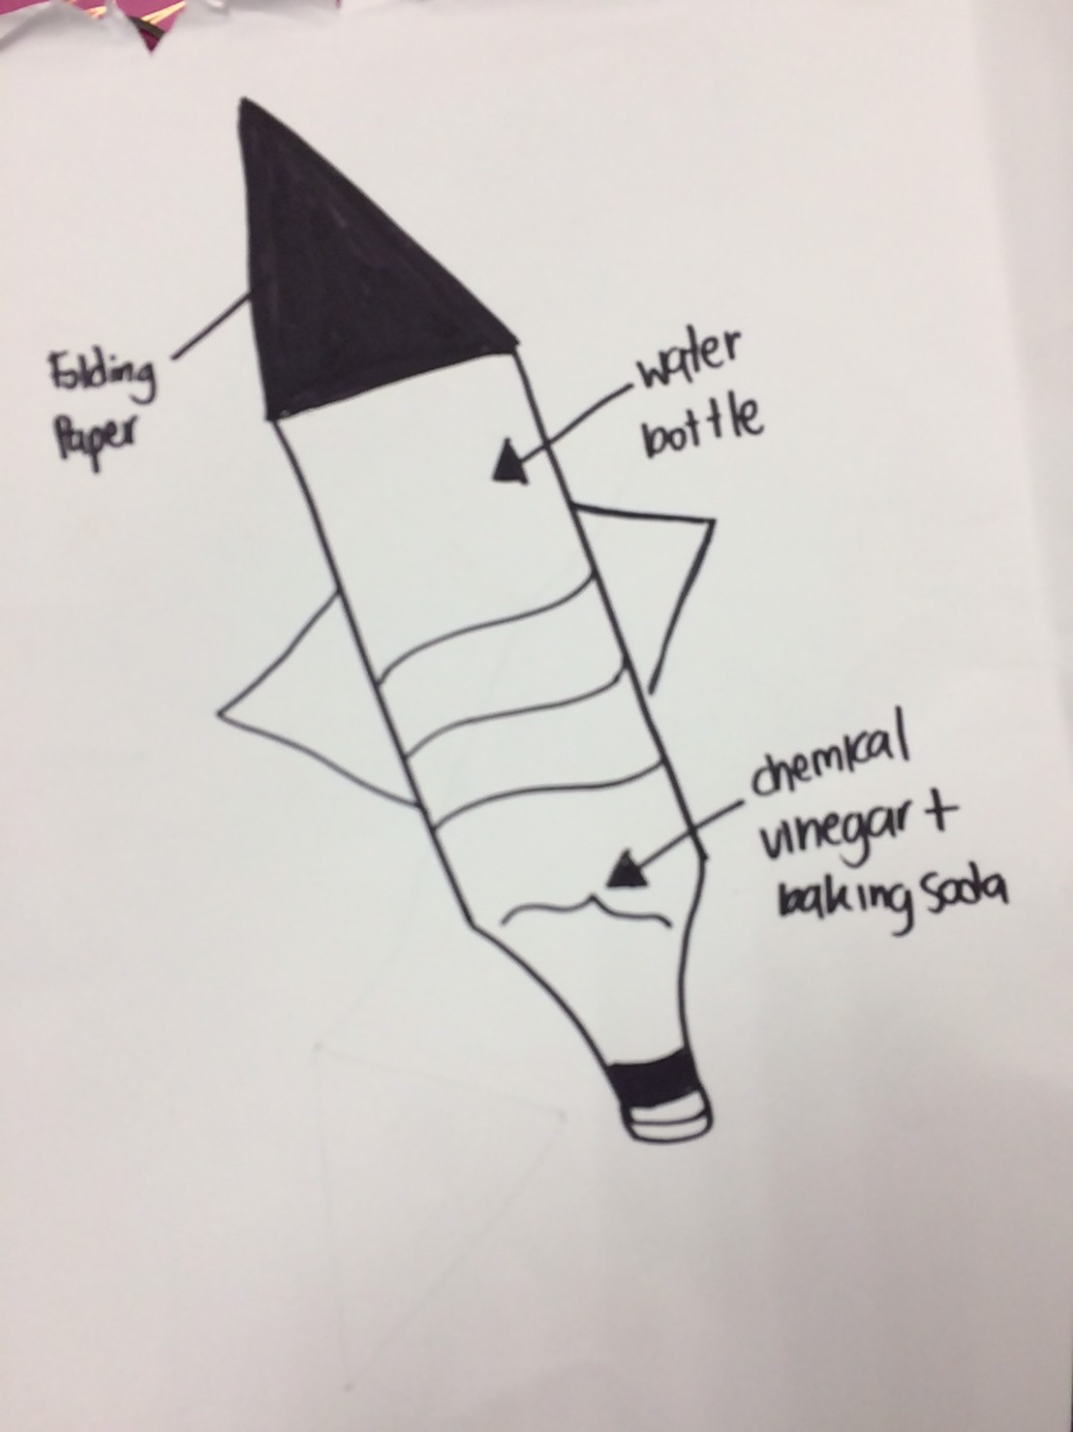

Background : Introduction

A rocket bottle is well known to be a project students tend to build in the attempt to demonstrate various concepts in Physics. We, as General Physics students, created a rocket bottle and a rocket launcher in order to study Physics concepts and apply them in real life. It may be important to keep in perspective that there is various background knowledge useful to understand in order to conduct the experiment effectively. The mentioned knowledge may extend to Newton’s Laws of Motion, momentum, impulse, projectile, etc. Newton came up with three Laws of Motion. The first one states: An object at rest stays at rest and an object in motion stays in motion with the same speed and in the same direction unless acted upon by an unbalanced force. The second one states: the vector sum of the forces F on an object is equal to the mass m of that object multiplied by the acceleration a of the object: F = ma. The final one states: for every action, there is an equal and opposite reaction. Real-life rockets including NASA’s can soar into the sky as a result of this law. The inserted force acts downward; the rocket moves upward. In conducting the experiment, the creators of this project aim to apply learned physics and chemistry concepts, and gain knowledge and experience along with fun in a hopefully productive time.

Discusstion of Physics Concepts

As stated, physics and chemistry play important roles in this experiment. The launching of the rocket can be explained by a chemical propulsion – a process in which thrust is generated by the product of a chemical reaction – involving baking soda and vinegar. The two chemical substances are reactants of an acid-base reaction which releases carbonic acid. The acid quickly breaks down into carbon dioxide and water. Soon after, the gas leaves the water which creates foam and bubbles. When the rocket is closed with the vine cork, a rapid increase of internal pressure is caused due to the fact that the gas cannot escape the rocket. Subsequently, the vine cork can no longer contain the gas. As the contents of the bottle shoot downward, the bottle itself shoots upward. This is a demonstration of Newton’s Third Law of Motion: for every action, there is an equal and opposite reaction.

Discussion of Design (Step by Step)

In the designing process, we did a research on wings design and the body itself. We’ve found out that to make the rocket fly at it best ability, the wings needs to be at the bottom-side of the rocket (close to where the lid was) which will provide lift for the rocket - as soon as the wings provide lift, the pressure will also be produced by the faster moving air. The tip of the rocket must be sharp enough to produce less air resistance and we also decide to put in a little piece of rock at the head to provide weight for the rocket to head down and land on the target. For the body, we decide to paint it black since the wings was red and they seems to go well together, also the body itself we use 2 bottle, cut and taped them together.

Data result

Mass of rocket | Distance cover | Angle of propulsion
126.62g | 14m | 35

Analysis of Data
Our rocket mass and design is suitable. Also, the quantity of chemical compound that putting in the rocket to make it fly is appropriate for the mass and the size of the rocket. However, we think that our problem is our launcher that unable to adjust the angle. Our launcher angle is 35 degree. That is the reason why our rocket cannot reach the target but it can only reach 14 meters as the furthest distance.

Conclusion and Recommendation

As we found that the ratio of baking soda and vinegar of 65:440 was the one that made our rocket going the furthest, there are still several factors that led to the result that our rocket didn’t hit the target. We believe we could have a more suitable ratio of the reactants, as well as a better adjusted angle of the launcher. As we now have demonstrated the practical form of Newton’s Law of Motion, we believe that the concept is significant and useful for human life.

Abstract

Our objective is to design a vinegar-baking soda rocket and to cooperate them with the appropriate concepts in physics. We begins with the manufacturing process - using water bottles, glue, cutter, plastic board, baking soda, vinegar, vine cock. After the making process is completed, we took them on a field test, the results we’ve got is quite impressive - mass was 126.62g total distance was 14m and the angle we use to launched was 35 degrees. We’ve came out with a solution that the quantity of chemical compound that putting in the rocket to make it fly is appropriate for both mass and size. However, our problem was the launcher angle can’t be adjusted - it was 35 degree fixed. That is the reason why our rocket cannot reach the target but it can only reach 14 meters as the furthest distance.

